**Course Project – Rough Draft**

Shaun Pritchard

Rasmussen College

G328/EVR3410

Marshall Bowles

June 14, 2020

**Course Project – Rough Draft**

Throughout this course, I studied and learned a great deal of information concerning many diverse topics about our environment and the effects we as humans have on this planet. through the collaboration of topics through this course, I wanted to create a final paper that would embody my previous work while also contributing to a new thesis.

There are several major environmental issues we face on this planet being Air pollution, Deforestation, Water pollution, Soil degradation. That are responsible for other issues such as GMOs(genetically modified organisms)(EP Online, 2020)*.*

In this research document, I will state my argument to persuade that all of these environmental issues we face are interconnected and dependently caused through industrialization, unchecked regulations, and exploitation.

Through my research, these issues seem to be the most pertinent cause for awareness and issues that we face today. Human uses of the environment have created detrimental impact on many aspects of this planet. All which have created an unbalance on this planet and for all the species who live on it.

As humans, we produce energy through industry and manufacturing to cater to our consumer-based culture and ideologies. We use energy to light our homes, power our mobile devices, and drive us to work. But what are the by-products of the production, consumption, and usage? What other practices have been modeled by other corporations, globalized industry, and politics to cater to the negative impacts and repercussions we now face?

The sources in which we utilize to produce this energy are critical to causing detrimental effects on this planet. We have been utilizing non-renewal energy sources like coal, nuclear, oil, and natural gases for decades.

These sources are found deep within the Earth presumably taking billions of years to produce. Then we have renewable sources of energy that replenish naturally and over a relatively short time. Such as wind turbines, solar, geothermal sources, and many others.

It is through the practice and consumption of non-renewable energy sources. We create vile by-products, unbalance, and destruction to this planet. Which affects cause atmospheric, air, ecological, and water pollution. Through industrial means being unregulated all over the planet. major global operations have exploited the natural resources to facilitate a bottom line.

This has caused an overloading of the atmosphere and ocean waters with carbon. Atmospheric CO2. Which absorbs and re-emits infrared-wavelength radiation, leading to warmer air, soils, and ocean surface waters which is technically good. The planet would be frozen solid without this. Unfortunately, there is now too much carbon in the air. Burning of fossil fuels, deforestation for agriculture, and industrial activities have pushed up atmospheric CO2 concentrations from 280 parts per million (ppm) 200 years ago, to about 400 ppm today; doubling the natural balance of our environment. That is an unprecedented rise in C02, in both size and frequency(DW, 2016)*.*

Carbon overloading is only one form of air pollution caused by burning coal, oil, gas, and wood. The World Health Organization recently estimated that one in nine deaths back in 2012 were attributable to diseases caused by carcinogens and other poisons in polluted air (WHO, 2020). If we look at the sources of where industrialization is going unchecked and where the most pollution is being produced from these means

How is the water affected through industrialization? How is pollution caused by both our oceans and natural freshwater resources on land? Through poor or unregulated industrialization, manufacturing and bad policies going unchecked. For the past eighty plus years, industries have been producing by-products from these unrenewable sources such as plastic.

Oil is not just burned for the power it is engineered into an array of plastics that now reside in mass garbage patches across our oceans. Mountains of waste and garbage overflowing in 2nd and 3rd world countries. Polluting local regions people and ecological systems with irreversible effects.

The chemical processes and by-products that create plastics have very harmful and proven effects. Plastics also put a big chemical burden on the environment. BPAs and microplastics are destroying our oceans and all the life-forms in them including humans. plastics products, food, and formula can linings, dental sealants, and on the shiny side of paper cashier receipts create BPA which is a weak synthetic estrogen. BPA's are causing detrimental effects and hormone changes in humans, wildlife, and ecosystems (Breastcancer.org, 2020).

Microplastics are any piece of plastic measuring five millimeters in size down to one micrometer, which is one-thousandth of a millimeter. Plastic particles that are smaller from one micrometer down to 100 nanometers. These are defined as sub-microplastic or nano plastics. The plastics have adverse health effects on humans as they move through the marine food web. Microplastics both absorb into the blood stream in humans and wild or sea life and give off chemicals and harmful pollutants (Tox Town, 2020).

All of these issues exist today because we have major industries operating in countries with little or no regulations. Policymakers even here in America are paid off by lobbyists and specialized bureaucratic organizations such as the FDA and EPA. Who take contributions to facilities regulations independently and preferential organizations. Laws are overlooked and standards are not kept. These issues are double-sided and disregarded by some while others are virtue and politicized with no sustaining real actionable results or little efforts are rarely taken.

**Should we blame industry?**

Though specific Industries are responsible for the energy production non-renewal sources in creating the overload Plastics and CO2 atmosphere. We see that these uncanny practices for globalized businesses have created unsustainable models in other businesses which are creating unnatural and unhealthy environmental traits.

Deforestation is where Species-rich wild forests [are being destroyed](https://www.dw.com/en/palm-oil-versus-paradise-in-papua/a-19518922), especially in the tropics, often to make way for cattle ranching, soybean or palm oil plantations, or other agricultural monocultures.

Today, about 30 percent of the planet's land area is covered by forests which is about half as much as before agriculture got started around 11,000 years ago. About 7.3 million hectares (18 million acres) of forest are destroyed each year, mostly in the tropics. Tropical forests used to cover about 15 percent of the planet's land area; they are now down to 6 or 7 percent. Much of this remainder has been degraded by logging or burning.

Not only do natural forests act as biodiversity reserves, but they are also carbon sinks, keeping carbon out of the atmosphere and oceans. While urbanization proves that 95% of the world’s population lives on only 10% of the land. Much more of this land is being destroyed at a faster rate causing unbalanced, pollution, and destroying biodiversity, fragile eco systems, and environments (DW, 2016).

           We can see that global industry companies have taken advantage and constructed business models with no regard to harm farmlands through the exploitation of harmful chemicals, product base industrial waste, and chemical manufacturing. Poising humans and the land with soil deprivation and GMOs.

There are more than 120 different varieties of (GMO) genetically modified crops that have been regulated in the United States (Genetic literacy project, 2020). The following chart, by the USDA Animal and Health Inspection Service, shows the variety of GMO crops that have been approved in the U.S. Genetically engineered crops have been approved for cultivation in the United States since the 1990s. Today, there are 10 GMO crops currently produced in the US, while more than 120 GMO seeds with unique traits have been deregulated. More than 90% of corn, soybean, cotton, canola, and sugar beet in the US is GMO (Genetic Literacy Project, 2016)

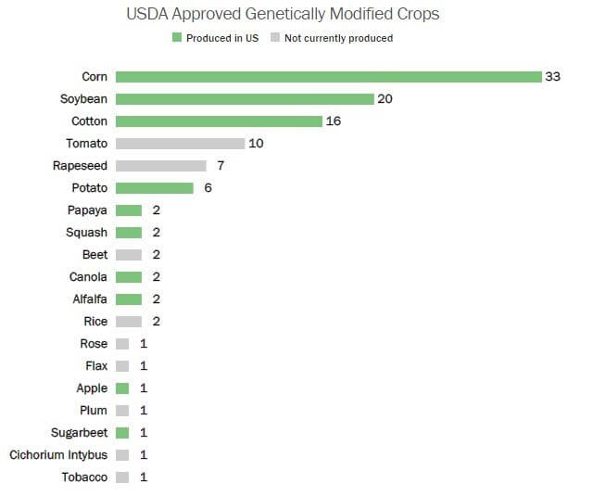

These are the current facts on GMOs being implemented into our agricultural today. To understand the position of my safety concerns in regard to GMOs I will need to provide some context. The methods in which GMOs are implemented, the chemical process used to conduct the modifications, the companies responsible for engineering modifications, and the deadly bio-chemicals being produced in our foods need to be explained.

Glyphosate is an active ingredient of the most widely used herbicides that is a toxic chemical responsible for cancers, abnormal cell growth, deterioration of estrogen receptors, which has resulted in the death of countless people.

Glyphosate is a chemical engineered by Monsanto in an herbicide called Roundup. they also genetically modify crops seeds with this deadly chemical which in turn results in designer seeds that can only be grown and brought to yield with Monsanto chemical products. Glyphosate-resistant, “Round-Up Ready” soybean, where the first to patent in 1994. Monsanto is a company that claims to be an agriculture company, but from the 1930s it has always been government-contracted biochemical manufacture *(Laksi, 2013).*

Monsanto's practices have not only been the result of shady practices and deadly engineering of genetic bio-chemicals that now reside on a mass portion of our daily food supply. they have altered healthy organic seed supplies with a chemically new genetic makeup that have been scientifically proven to alter human genetics. Also, their seeds have locked down the control of the seeds & food supply markets in which they now control through lofty patents on seeds that infringes farmers, and people's rights to life and choice *(EWG, 2016*).

The United States Patent and Trademark Office, for practically all of its history, refused to grant patents on seeds, viewing them as life-forms with too many variables to be patented. However, in 1980, the U.S. Supreme Court allowed for seed patents. This laid the groundwork for corporations like Monsanto to start gaining control of the global food supply *( US Supreme Court, 1980).*

Over the past 15 years or so, a collection of five giant biotech corporations - Monsanto, Syngenta, Bayer, BASF, Novartis, Pizer, Purdue, Dow, and DuPont. They have bought up more than 200 other companies, allowing them to dominate access to seeds and pharmaceutical technology *(Organic Consumer Association, 2014)*and controlling major domestic and foreign farmlands.

**Cause and Effect**

It is thorough the means of corrupt industrialization and total disregard for sustainability. Companies for too long have used their finical power to build business models with repercussions for their action on the environment. The industrialized Energy production practices and industrialized products from nonrenewable and chemical sources have been the major cause for these issues to facilitate bottom lines, not sustainability.

Though several attempts which mainly came about for political reasons offering no real substantial solutions existed like the Paris climate agreement. I believe we need to implement a real agreement where all countries, industries, and people are held accountable to the same level. I also believe we should establish an energy policy to facilitate these changes with real action.

**The Paris Accord an attempt to sustainability or politics?**

As a student of Science aspiring to be a data & math scientist specifically. I find relevancy in the process of due diligence, researching, and studying. The face value and mainstream narratives would suggest that the Paris agreement facilitates the change that we are all wanting. After reading the Paris agreement and many other supporting factual documents my concussion is to reject the notion of the Paris agreement. Here is the latest data that shows the level of co2 emissions:

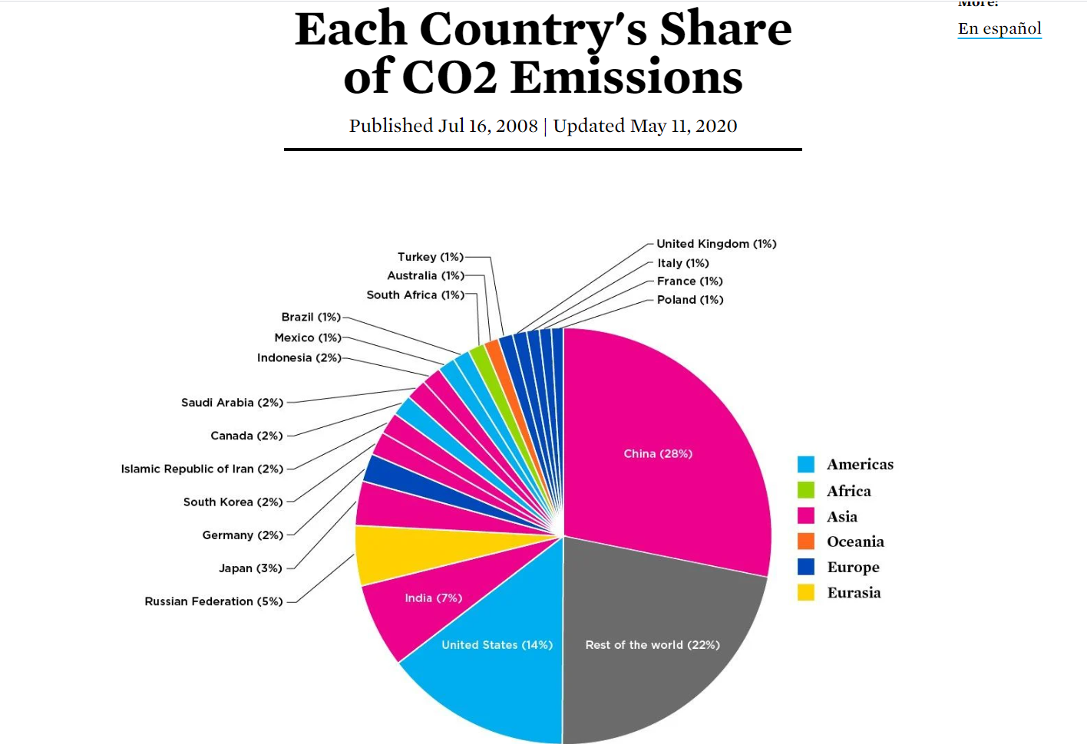

CO2 emissions for each country in 2020 *(UCSUSA, 2020)*. China leads as the number one most pollutant country on the planet followed by India, the United States of America, Russia, Japan, and so on.

           China accounts for 28% over a quarter and nearly half of the world's co2 emissions because of unchecked Industry growth that has become seriously dangerous to this planet. Polluting more than any other country in the world *(Active Sustainability, 2020)*. China also has levels of air pollution in its cities that cause 350,000–400,000 premature deaths per year. Another 300,000 died because of indoor air of poor quality *(Wikipedia, 2020)*. There were 60,000 premature deaths each year because of water pollution, industrial runoff, and poor air quality *(Climate Action Tracker, 2020)*. China is also listed as the world’s deadliest country for outdoor air pollution, according to an analysis by the World Health Organization (WHO) *(The Guardian, 2016)*. The USA follows suite not because of manufacturing an industry growth but because of western civilization-based consumer habits and industry at 17% co2 emissions. India like China has unchecked non-regulation-based industries and no accountability for the environment, runoff, or local habitats. accounting for 7% co2 emissions on the planet *(Ceasepollution.com, 2020)*. India is also on the list of the most polluted cities in the world. As per a study based on 2016 data, at least 140 million people in India breathe air that is 10 times or more over the W.H.O safe limit*(Newsy.com, 2020)*.

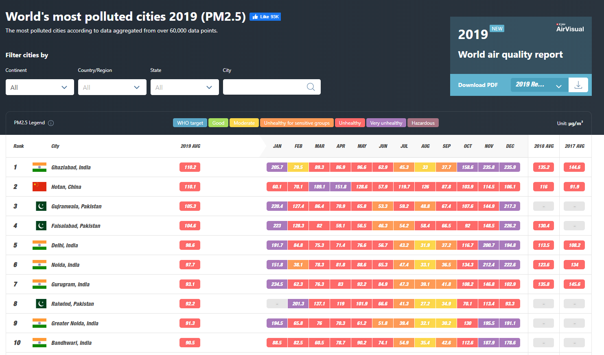

The data above is to discern a point and simply show that America does not stand alone as being the only co2 emitting country let alone the only dangerous polluting country on the planet *(IQAIR, 2020)*. Also, it not the worst in comparison to other countries like China and India.

A climate agreement should be based on actionable regulation to all countries equally involved. To tackle the diverse issues of climate change and pollution with viable resolutions. The Paris agreement does not facilitate actionable, oversight, or pragmatic solutions. The Paris climate agreement was deeply flawed from its start. It was legally and constitutionally suspect, based on politics rather than science, facts, and contained unrealistic goals. It promised not only a dramatic expansion of the administrative state and a huge increase in the regulatory burden on American businesses, but it also threatened to put the brakes on U.S. economic output at a time when most economists think the U.S. will struggle to achieve even a meager two percent growth *(Heritiage.org, 2017).*

The Paris agreement would allow China to be able to increase its emissions and continue to develop new industries without regulations completely unchecked for the next 13 years with capacity building implementations in article 11 of the accord *(unfcc, 2015).* India and other developing countries can only contribute to the agreement with foreign aid from America, not China or Russia. By contrast, China committed to boosting non-fossil fuels to around 20% of its overall energy by 2030, but China’s Emissions have grown exponentially since the Paris Agreement was signed in 2015 *(Pew Research Center, 2015)*. due to implementing more usage of non-renewable coal sources. China’s CO2 emissions grew faster in 2018 than the 1.7% growth in 2017, according to studies *(Carbonbrief.org, 2019)*. While America's emissions have decreased by 0.3% *(Climateactiontracker.org, 2020)*.

The Paris agreement was an attempt to halt climate change on the honor system. Its only legal requirements were for signatories to announce goals and report progress, with no international enforcement mechanism. As a result, it was likely that the United States and wealthy European nations would have adopted and implemented severe climate change rules while many of the world’s governments would avoid doing anything that would slow their economies as proved since 2015.

The Paris Agreement is highly cost to the American people and would not prove to yield the results anticipated through the initiative in addressing climate change. The regulations necessary to implement the Paris agreement would have cost the U.S. industrial sector 1.1 million jobs, according to a study commissioned by the U.S. Chamber of Commerce. The Heritage Foundation study found that the Paris agreement would have increased the electricity costs of an American family of four by between 13% and 20% annually. It forecast a loss of income of $20,000 by 2035. In other words, American families would be paying more while making less *(Heritiage.org, 2017)*.

The overall effect of the agreement would have been to reduce U.S. GDP by over $2.5 trillion and eliminate 400,000 jobs by 2035, according to Heritage’s study*(Heritiage.org, 2017)*. This would exacerbate problems with government funding and deficits, make Social Security solvency more challenging, and increase reliance on the government’s spending to support households. The Paris conference, participants called for a Green Climate Fund that would collect $100 billion per year by 2020 *(American Thinker, 2018)*. This is only what American taxpayers would have had to pay. While other countries were not under any terms to contribute funds. There are also stipulations about the United Nations and Conference of the Parties based on the U.N which would extend sovereign authority and authority into America.

After studying the agreement and researching many opposing, contradictory, and supporting arguments *(unfcc, 2015).* I believe the initiative is on the right track, but there's just too many holes in the agreement, no accountability, no commutative correlation to bind countries together equally, and the burdens of resources and finances weigh too heavy on America as opposed to the other leading countries.

I believe we need an agreement in place with real actionable milestones to achieve real actionable goals to tackle this problem. There needs to be some oversight that does not burden the people of select nations, but the industries which are solely responsible for causing the harm in the first place. Maybe more incentive, innovation, and collaboration with a system in place that shares responsibility accordingly and evenly amounts to the top and developing countries? I honestly think we can do a lot better if we come together without the bureaucracy, red tape, and politics.

**Should we have policies for energy production?**

I believe having a national energy policy would be a very good idea. With that being said there would be many things that we have to attribute and keep an eye on. Many policies get politicized and many corporations with spending power can buy their ways out of specific situations regarding avoiding sustainability. We would need a policy that would not attribute lobbyists nor private incentives. Politics would need to be removed for the common good!

We would also have to consider the factors of legality in that we would not propose any infringements of consumers' or organizations' rights or that denies specific companies or organizations protected freedoms. National energy policy would need to be rigorous in exclaiming a unified plan that would involve a common goal. It would need to facilitate a way for people to continue to aspire and strive for higher standards of living with greater freedom and dignity. While transforming our current infostructure and practices to more sustainable actions that would reduce energy and resources.

Allocate resources to develop a phased mission capable and unique enough to involve the entire nation its people, and companies that make up the nation. I do not believe this is one way in which we would Implement specific practices for certain organizations and not consumers or only to consumers and not specific organizations.

Break down common factors of states and locality, use data to drive metrics in tracking the operation, resources for public and commercial purposes, and incentivize for each faction.

Set aside grievances and petty differences. Stop allocating blame and start working on unified solutions to solve issues once they are identified or ones that have been known. furthermore, we would need a government initiative to bring us all together while keeping their place as a representation or an extension of the people for this work correctly.

**How would you construct this Energy policy?**

To establish a sound national energy policy first, we would need to implement the stated problems in a format we can build a solution upon. dividing out specific variables that facilitate and embody the principles standards of national policy as described above with a common goal. The common goal to reduce energy, waste, and usage that would involve new sustainable practices while implementing Innovation and incentives that facilitate environmentally sound utilization and sustainability. Through this, we could seek balance in government, infrastructure, business, and private consumer levels.

If a national policy existed that incentives and declared that all infrastructure energy sources in respected states and areas. To utilize and transform into renewable energy sources first. Implement action to phase out the nonrenewable energy source. Only using these sources for back up and emergency.

It is reported that it would take $4.5 trillion to convert USA infrastructure to 100% renewable energy source over the next 10 years. *(E360, 2019)*. So where can we get this money? How can businesses stay in business for transforming? What creative ways can we help adjust for this cost, to take action, and make it a reality?

Formulate best practices, incentives, and overhaul audit systems for each type of business setting sustainable guidelines. Giving them a choice to sign up and pledge new sustainable practices. There are 4 types of business Service, product, manufacturing, and hybrid *(Accounting Verse, 2020)*. The government can use incentives, tax breaks, and recognition to create public awareness of those companies who pledge to practice more sustainable acts.

New protocols or audit systems tracked and implemented through data analysis and technology could provide public resources of awareness. We would need to find a way to split the cost attributed to the public deficit and make it worth the company owner's time.

Essentially if companies pledged to a unified movement through the policy to use sustainable resources, services and followed the new protocols for their respected industry. Companies could receive tax incentives to lower their product prices making it more efficient for consumers to make buying decisions at a lower cost. Where are those businesses that did not follow the trend would still have the choice at the risk of the markets?

To break this problem down we need to infer a multipart polynomial equation based on consumers, business, government, and infrastructure. Ultimately, we need a policy that would incentivize the transformation of nonrenewable energy sources and technology to renewable energy sources. Renewable energy sources have proven to be more efficient. The only catch is that the cost of business to convert could cost time, resources, and money that would set a business back.

We need to devise a phased program that would incentives using natural sustainable renewable energy (solar, hydro, thermal) solutions as primary energy sources. while utilizing non-renewable energy (oil, natural gas, coal) as backups only needed for emergencies. We would need each state to use data-driven practices to permeate results that facilitate the common end goal or transformation over 10 years. Also, to implement a new audit system for the variety of businesses to implement sustainable practices within their business and provide public information to incentivize consumers to make smarter purchases with companies who are converting and following more sustainable guidelines.

**Phase I** - Implement stated problems, collect information on each state energy needs, calculate resources to convert to more sustainable infrastructure, running the inferences based on each State's Collective needs divided by the collective end goal of the nation, discuss incentives, planning, and development of consumer-level data resources, calculate which enable sources are available for specific states, calculate resources, time, and finances needed for each state to comply and transform, establish deadlines, policies to incentivize companies transforming, and higher rate, taxes, and locks on trade and contracts for those. From a government level, we could create a department to implement oversight and see this through.

**Phase II** – Implement the transformation. This is where we phase out the conversion maximums of enabling renewable energy (solar, hydro, thermal). Implement infrastructure overhaul and business who may switch services and practices. Use marketing to highlight companies, manufactures, and infrastructure making the change to keep them in a positive light.

**Phase III** – Complete transformations while setting new benchmarks to refine sustainability within business, manufacturing, services, public, and infrastructure.

Out of 50 states in each state, we have commercial and public sectors. Each state has different factors that create unique problems on their own. States have different seasons, weather patterns, and needs for diverse energy resources concerning their demand in public use and manufacturing. All related to the multiple respected levels of consumers, business, government, and infrastructure

**Consumer-level** – To implement resources and data-driven solutions that could bring public awareness to those companies spending time and resources on the transformation. We as consumers and private citizen need to make conscious decisions on how to use our buying power with those companies seeking to transform

**Business level** – Rethinking technology cost a lot of money, time, and resources there are over 30 million smalls to mid-sized business in the U.S.A with under 500 employees. Provide lifeblood to our nation and the world *(Fundera, 2020)*. and only 8000 major global size cooperation with more than 500 employees *(Fundera, 2020)*. Typically, major businesses set up manufacturing overseas in countries like China where there is no environmental regulation, cheap labor, and no taxes. We need these businesses to attract more money, value, and success for being sustainable here in the U.S.A.

**Government** – essentially the gatekeepers of information, public awareness, and resources to be used and implemented to converting the infostructure and providing incentives through tax breaks, accountability, recognition, and business. Our government would need to choose sustainable companies and contractors over non-sustainable countries. This would set the benchmark and example for business owners to follow. This variable would need to cut out bloated bureaucracy and politicization.

**Infrastructure** – Currently we have technology in place and are only utilizing 18% of our potential through renewable energy sources. We need to find a way to incentivize a transformation that will not cost businesses to lose money and will employ new implementations on resources to sustain them moving forward as shown from the U.S Energy

Information Administration below *(U.S Energy Information Administration, 2020).*

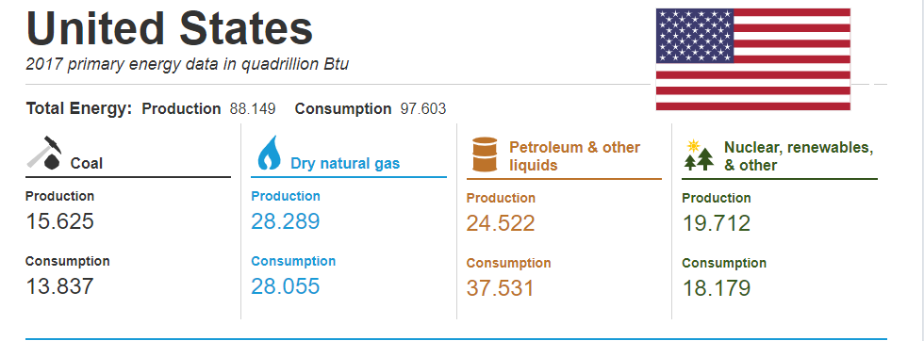

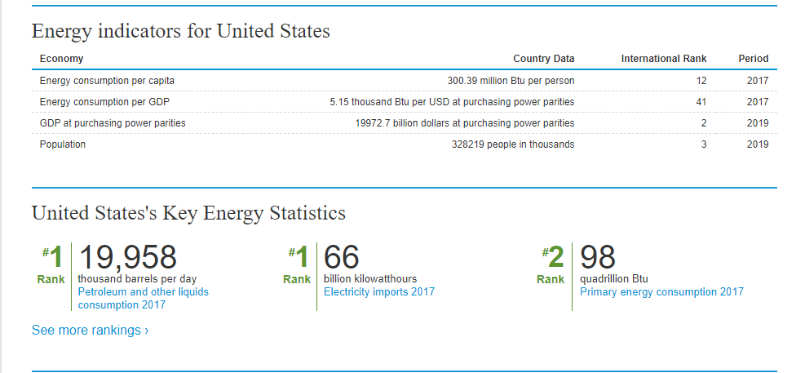

This policy would have to implement structure and new capability requirements for each category factor. Innovation, transformation all takes time and money. If we could allocate resources to those making the effort as opposed to those who are not trying. We create a fair market environment. Regardless it is in my personal opinion that some action needs to be taken. There are many ways in which a new trend followed by sound practices as suggested above can facilitate this change. We need to move beyond awareness to achieve this and attain perspective and balance.

We need to spark a trend that will incentivize business, incentivize innovation, and incentivize the people to take part in making better-informed decisions. One day I would like to see new technology that would let us recycle and clean plastic at our homes. To ether sell back cleaned material or use in 3D printing.

 I would like to see major global business and small corporations ensuring they are not cutting corners. Bringing real value to the market through new products and services that follow sustainable practices people can trust. For the ability for America to set the standard for the rest of the planet to follow suit. Ensuring everyone is doing part to reduce the maximum amount of waste and energy.

**Can we fix our planet?**

Although we can pinpoint where the damage is coming from. We can see that the actions of some policies and agreements are too vague and play favoritism. The question is how can we persuade the leaders of these countries to have any regard for the environment and the damage industries are and have caused?

How can we get globalized industries to take action to spend time and resources cleaning up the plastics, chemicals, and pollution they created. I believe we need a starting point to adapt such trends. If the energy sectors where to take lead and implement policies as such. They could set new models for global business to adhere.

While although we as consumers use these products and should take immediate action on becoming aware, implanting satiable technologies, practices, and oversight. This will only work if every cog in the machine does its part. I think it needs to start with educating the individual as well, but also with those, we elect to represent us first and foremost to prove their words are worth the votes that elected them with viable clear actions. The ability to set aside politics and work together compromising instead of pandering division. To have some kind of accountability and sense of urgency that is backed with scientific fact and oversight.

# References

US Supreme Court. (1980, 3 17). *Diamond v. Chakrabarty, 447 U.S. 303 (1980).* Retrieved from Justia.com: https://supreme.justia.com/cases/federal/us/447/303/

Active Sustainability. (2020). *Top 5 most polluting countries*. Retrieved from www.activesustainability.com: https://www.activesustainability.com/environment/top-5-most-polluting-countries/

American Thinker. (2018, 12 31). *China and the Paris Accord*. Retrieved from https://www.americanthinker.com: https://www.americanthinker.com/blog/2018/12/china_and_the_paris_accord.html

Breastcancer.org. (2020). *Exposure to Chemicals in Plastic*. Retrieved from https://www.breastcancer.org: https://www.breastcancer.org/risk/factors/plastic#:~:text=BPA%20is%20a%20weak%20synthetic,many%20other%20chemicals%20in%20plastics.

Breitbart. (2017, 06 1). *Top 7 Worst Reasons to Keep the Paris Climate Accord*. Retrieved from https://www.breitbart.com: https://www.breitbart.com/politics/2017/06/01/top-7-worst-reasons-keep-paris-climate-accord/

Carbonbrief.org. (2019, 03 5). *China’s CO2 emissions grew slower than expected in 2018*. Retrieved from https://www.carbonbrief.org: https://www.carbonbrief.org/guest-post-chinas-co2-emissions-grew-slower-than-expected-in-2018

Ceasepollution.com. (2020). *Top 10 Biggest Polluters in The World*. Retrieved from https://ceasepollution.com/: https://ceasepollution.com/top-10-biggest-polluters-in-the-world

Climate Action Tracker. (2020). *China Climate Action Tracker*. Retrieved from https://climateactiontracker.org: https://climateactiontracker.org/countries/china/

Climateactiontracker.org. (2020). *USA*. Retrieved from https://climateactiontracker.org: https://climateactiontracker.org/countries/usa/

DW. (2016). *Five of the world's biggest environmental problems*. Retrieved from https://www.dw.com/: https://www.dw.com/en/five-of-the-worlds-biggest-environmental-problems/a-35915705

EP Online. (2020, 02 24). *Five Biggest Environmental Issues Affecting the U.S.* Retrieved from https://eponline.com: https://eponline.com/Articles/2020/02/24/Five-Biggest-Environmental-Issues-Affecting-the-US.aspx?Page=3

EWG. (2016, 3 2). *Purdue's GMO Study: Biased Data, Bogus Findings*. Retrieved from www.ewg.org: https://www.ewg.org/agmag/2016/03/purdues-gmo-study-biased-data-bogus-findings

Genetic literacy project. (2020). *Which genetically engineered crops and animals are approved in the US*. Retrieved from gmo.geneticliteracyproject.org: https://gmo.geneticliteracyproject.org/FAQ/which-genetically-engineered-crops-are-approved-in-the-us/

Gentic Literacy Project. (2016). Which genetically engineered crops and animals are approved in the US? *Gentic Literacy Project*, 2. Retrieved from geneticliteracyproject.org: https://gmo.geneticliteracyproject.org/FAQ/which-genetically-engineered-crops-are-approved-in-the-us/

Heritiage.org. (2017, 06 01). *4 Reasons Trump Was Right to Pull Out of the Paris Agreement*. Retrieved from https://www.heritage.org: https://www.heritage.org/environment/commentary/4-reasons-trump-was-right-pull-out-the-paris-agreement

IQAIR. (2020). *World's most polluted cities 2019 (PM2.5)*. Retrieved from https://www.iqair.com: https://www.iqair.com/world-most-polluted-cities

Laksi, B. (2013). Glyphosate induces human breast cancer cells growth via estrogen receptors. *US National Library of Medicine National Institutes of Health*, 3.

NASA. (2015, 10 30). *NASA Study: Mass Gains of Antarctic Ice Sheet Greater than Losses*. Retrieved from www.nasa.gov: https://www.nasa.gov/feature/goddard/nasa-study-mass-gains-of-antarctic-ice-sheet-greater-than-losses

NASA. (2015, 10 30). *NASA Study: Mass Gains of Antarctic Ice Sheet Greater than Losses*. Retrieved from Nasa.gov: https://www.nasa.gov/feature/goddard/nasa-study-mass-gains-of-antarctic-ice-sheet-greater-than-losses

Newsy.com. (2020, 02 25). *1 Of Top 30 Air Polluted Cities Last Year Were In India*. Retrieved from newsy.com: 1 Of Top 30 Air Polluted Cities Last Year Were In India

Organic Consmer Associaition. (2014, 2 10). *Seeds of Evil: Monsanto and Genetic Engineering*. Retrieved from www.organicconsumers.or: https://www.organicconsumers.org/news/seeds-evil-monsanto-and-genetic-engineering

Pew Research Center. (2015, 10 24). *Corruption, Pollution, Inequality Are Top Concerns in China*. Retrieved from https://www.pewresearch.org: https://www.pewresearch.org/global/2015/09/24/corruption-pollution-inequality-are-top-concerns-in-china/

The Guardian. (2016, 10 27). *China tops WHO list for deadly outdoor air pollution*. Retrieved from https://www.theguardian.com: https://www.theguardian.com/environment/2016/sep/27/more-than-million-died-due-air-pollution-china-one-year

Tox Town. (2020). *What are Microplastics?* Retrieved from https://toxtown.nlm.nih.gov: https://toxtown.nlm.nih.gov/sources-of-exposure/microplastics

U.S Energy Information Administration. (2020). *Total Energy Consumption*. Retrieved from www.eia.gov: https://www.eia.gov/international/overview/country/USA

UCSUSA. (2020, 04 11). *Each Country's Share of CO2 Emissions*. Retrieved from https://www.ucsusa.org: https://www.ucsusa.org/resources/each-countrys-share-co2-emissions

unfcc. (2015). *The Paris Agreement*. Retrieved from unfcc.int: https://unfccc.int/files/essential_background/convention/application/pdf/english_paris_agreement.pdf

WHO. (2020). *WHO: Nine of 10 people breathe bad air*. Retrieved from https://www.dw.com/en/who-nine-of-10-people-breathe-bad-air/a-35898832: https://www.dw.com/en/who-nine-of-10-people-breathe-bad-air/a-35898832

Wikipedia. (2020). *Pollution in China*. Retrieved from https://en.wikipedia.org: https://en.wikipedia.org/wiki/Pollution_in_China#:~:text=High%20levels%20of%20air%20pollution,of%20water%20of%20poor%20quality.&text=China%20has%20made%20some%20improvements%20in%20environmental%20protection%20during%20recent%20years.